A

Project Report on

**Himalayan Hills Website Adding Chabot Watsonx Studio**

Submitted in partial fulfillment of completion of the course

Advanced Diploma in IT, Networking and Cloud Computing

Submitted by:

**Archana Kumari**

Under Guidance of:

**Arpita Roy (Edunet)**

|  |  |  |
| --- | --- | --- |
| C:\Users\ibmuser\AppData\Local\Microsoft\Windows\INetCache\Content.MSO\2C3D7B61.tmp | C:\Users\ibmuser\AppData\Local\Microsoft\Windows\INetCache\Content.MSO\13EB517.tmp | C:\Users\ibmuser\AppData\Local\Microsoft\Windows\INetCache\Content.MSO\99B363D.tmp |

Year 2023

**PROJECT OVERVIEW**

Abstract

Acknowledgement

Table of Contents

1. Introduction to Problem
2. Proposed Solution
3. Requirements

4.1 Technology Stack

4.2 Hardware

4.3 Software

4.4 Deployment Environment

5. User Requirements

6. Design Documentation

7. Implementation Details

8. Testing

9. Deployment

10. Future Scope

11. Conclusion

Appendix A Screenshot of Project

References

**ABSTRACT**

This project aims to enhance the user experience on our Himalayan Hills website by integrating a chatbot powered by IBM Watson Assistant through Watson Studio on IBM Cloud. The chatbot serves as an intelligent virtual assistant, providing instant and personalized responses to user queries related to the Himalayan Hills and associated services. Leveraging IBM Cloud's Watson Studio, we deploy a robust and customizable solution that incorporates natural language processing (NLP) capabilities, allowing seamless communication between users and the chatbot.

The integration of Watson Assistant enhances user engagement, facilitates efficient information retrieval, and contributes to an overall improved interaction on our Himalayan Hills website.

**ACKNOWLEDGEMENT**

We would like to express our sincere gratitude to all those who have supported and contributed to the successful completion of this project. Your assistance and encouragement have been invaluable throughout this journey.

First and foremost, we want to thank my project supervisors, Arpita Roy(Edunet) for their guidance, expertise, and unwavering support. Their insights and feedback have been instrumental in shaping the direction of this project.

We would also like to extend my appreciation to my fellow classmates who provided valuable input, shared resources, and engaged in stimulating discussions that enriched the project. Your collaborative spirit was a driving force behind our achievements.

Furthermore, we want to acknowledge our friends and family for their patience, understanding, and encouragement throughout this endeavour. Your support provided the motivation we needed to see this project through to its completion.

Last but not least, we are grateful to the entire faculty and staff of NSTI Kolkata for providing a conducive learning environment and the necessary resources to undertake this project.

This project has been a rewarding learning experience, and we are thankful for the collective efforts of everyone involved. Your support has been instrumental in making this project a reality.

Archana Kumari,

NSTI KOLKATA

03/10/2023

**INTRODUCTION TO PROBLEM**

 As we strive to elevate the user experience on our Himalayan Hills website, we recognize the need for a dynamic and responsive solution to address user queries and provide real-time assistance. Traditional customer support methods often fall short in delivering timely and personalized responses. To bridge this gap, we have decided to integrate a chatbot into our website, leveraging the capabilities of IBM Cloud and Watson Studio's Watson Assistant.

Watson X Studio on IBM Cloud, we intend to create a sophisticated chatbot that not only understands natural language but also adapts to user preferences over time. This project addresses the need for an interactive and user-friendly interface that can offer information, suggestions, and assistance seamlessly, enhancing the overall user engagement and satisfaction on our Himalayan Hills website. Through this initiative, we aim to provide an innovative and effective solution to the challenges associated with user interaction and information retrieval.

**PROPOSED SOLUTION**

Integrate an IBM Cloud-powered chatbot into the Himalayan Hills website using Watson X Studio. Leveraging Watson Assistant's natural language processing, the chatbot ensures immediate, personalized responses. The user-friendly interface allows dynamic learning, adapting over time. With a focus on information retrieval, recommendations, and multi-channel accessibility, this solution enhances user engagement and provides analytics for continuous refinement.

**REQUIREMENTS**

**TECHNOLOGY STACK**

* Frontend static website.
* Programming Languages: , HTML, CSS, and JavaScript
* Cloud Platform: IBM Cloud
* Development Tool: Watson X Studio
* Chatbot Framework: Watson Assistant

**HARDWARE**

* Server: A dedicated server or cloud-based virtual machine (VM) toibm cloud
* CPU and RAM
* Storage: Adequate storage space for the database, application code, and uploaded files.
* Network Infrastructure: Reliable internet connectivity, firewalls, and security measures to protect the system.

**SOFTWARE**

* Operating System
* .html css javascripts
* IBM CLOUD
* OBJECT storage
* Version Control Tools: GitHub or GitLab
* Web Server

**DEPLOYMENT ENVIRONMENT**

* The size and complexity of the project
* The security requirements of the project
* The budget for the project
* The technical expertise of the team

**USER REQUIREMENTS**

* Mobile Accessibility or PCs
* Internet Access
* Supported Browser
* Agreement to Terms

**DESIGN DOCUMENTATION**

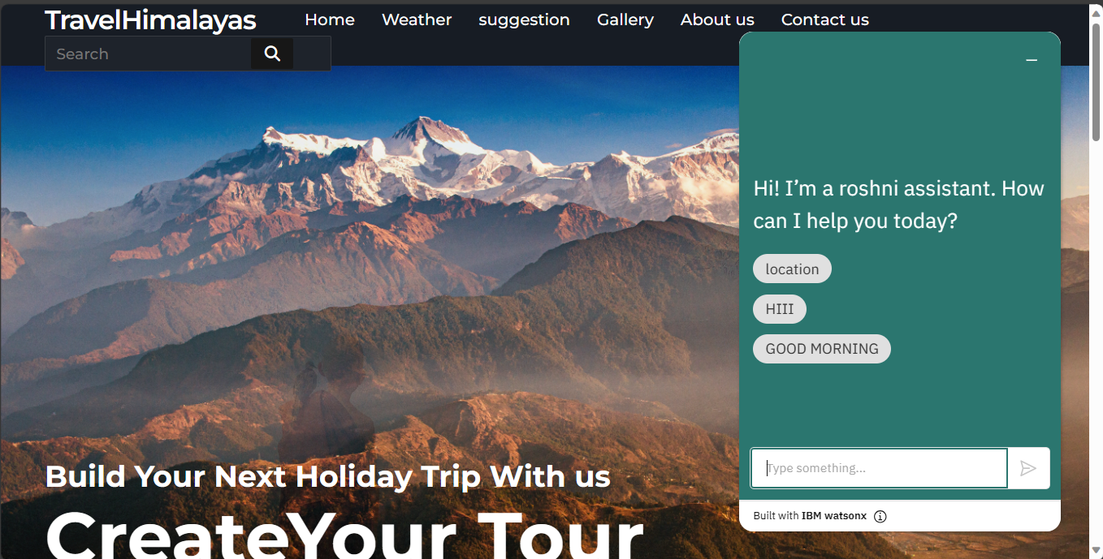

**Step 1: Setup and Dependencies**

**IBM Cloud Account:**

Create an account on IBM Cloud (https://cloud.ibm.com/) to access cloud services.

**Watson Studio**:

Set up a project in Watson Studio (https://www.ibm.com/cloud/watson-studio) to leverage Watson

Assistant.

**Watson Assistant Service:**

Create a Watson Assistant instance in Watson Studio and configure it to design and train the chatbot.

**Integration with Himalayan Hills Website:**

Embed the generated chatbot code into the Himalayan Hills website for seamless integration.

**API Key and Credentials**:

Obtain API key and credentials from IBM Cloud to authenticate and access Watson Assistant.

**Web Development Environment:**

Use a suitable web development environment to modify and enhance the website code for chatbot integration.

**Internet Connectivity:**

Ensure a stable internet connection for real-time interaction with IBM Cloud services.

**Browser Compatibility:**

Verify that the Himalayan Hills website is compatible with major browsers for a consistent user experience.

**Testing Environment:**

Set up a testing environment to validate the chatbot's functionality and responsiveness on the Himalayan Hills website.

**Documentation:**

Maintain documentation for setup, configuration, and integration processes for future reference.

Ensure all dependencies are met, and follow the documentation to seamlessly integrate the IBM Cloud-powered chatbot into the Himalayan Hills website using Watson X Studio.

**TESTING**

**SCREENSHOT OF PROJECT**

**This is my overall how to create chat bot in ibm cloud project image**

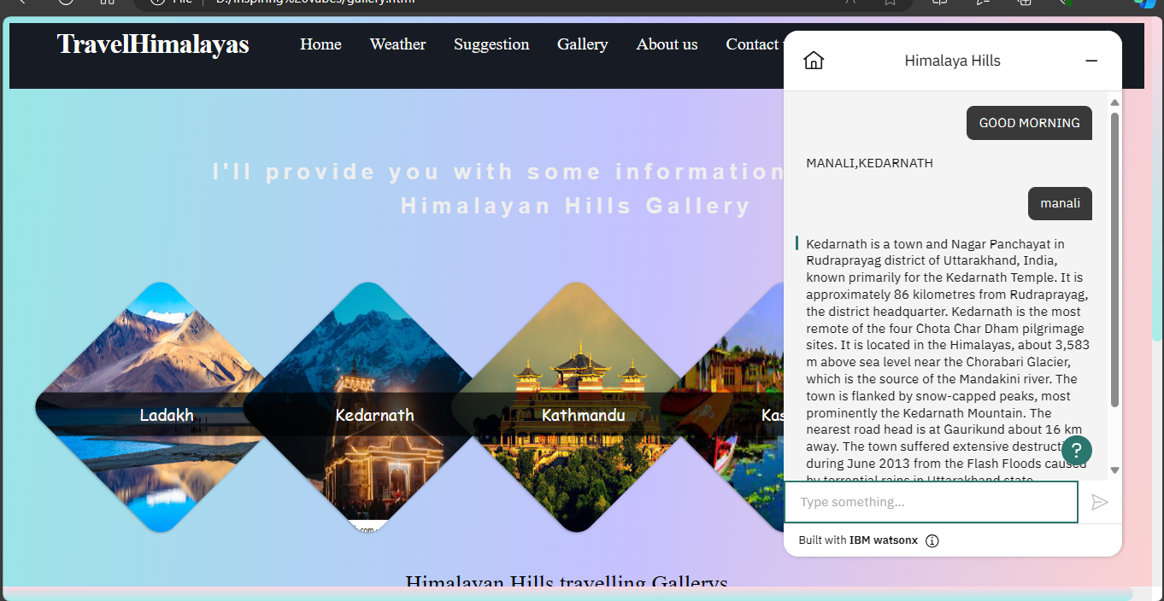

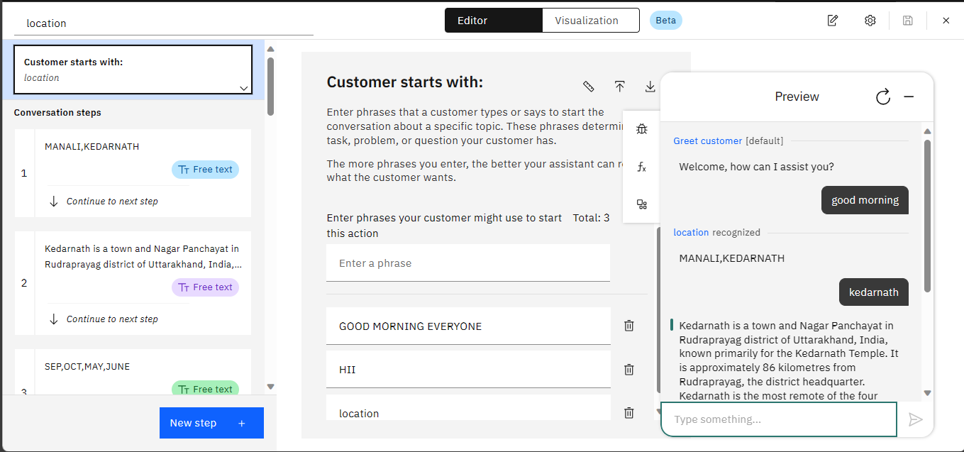

**FUTURE SCOPE**

**Advanced Personalization:** Tailor chatbot responses for enhanced user engagement.

**Multilingual Support:** Extend language capabilities for diverse user accessibility.

**Integration with Additional Services:** Explore broader service integrations for expanded functionality.

**Voice and Speech Integration:** Enable voice commands to enhance user interaction.

**Machine Learning Enhancements:** Improve understanding and learning capabilities.

**Real-time Analytics:** Implement analytics for continuous insights and improvements.

**Social Media Integration**: Expand chatbot reach through integration with social media.

**E-commerce Integration:** Integrate e-commerce functionalities for user convenience.

**Offline Functionality**: Develop offline mode for basic information access.

**Continuous Monitoring**: Ensure ongoing monitoring, maintenance, and updates.

**CONCLUSION**

Implementing advanced features in the Himalayan Hills website's IBM Cloud-powered chatbot using Watson X Studio promises enhanced user engagement, accessibility, and adaptability. Continuous learning, multilingual support, and integration with diverse services will ensure the platform remains innovative, catering to evolving user needs. This strategic evolution solidifies the website's commitment to technological excellence for sustained user satisfaction.

**REFERENCES**

[1] TravelHimalayas